BRYNLLYWARCH HALL SCHOOL
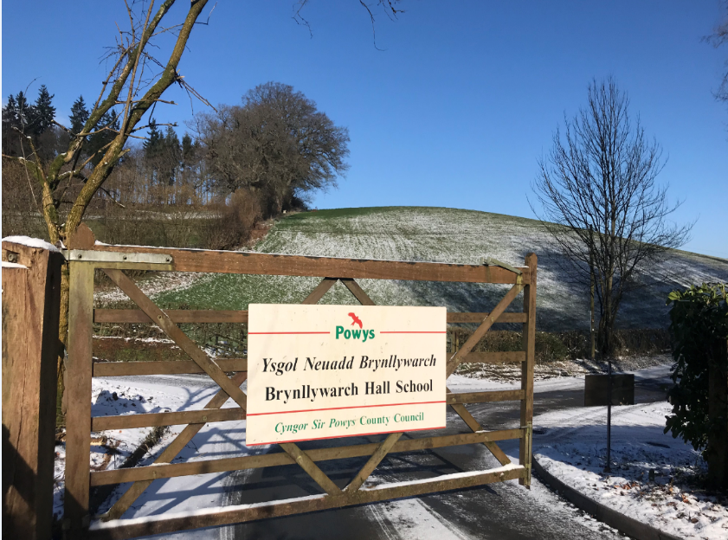
YSGOL BRYNLLYWARCH
Prospectus
2021/2022

Contents

Welcome to Brynllywarch Page 3
School Vision Page 4
School Details Page 5
Admissions Page 6
Home-School Agreement Page 6
Curriculum Page 6
Qualifications Page 8
Outreach Service Page 11
Pastoral Care Page 12
Reward System Page 12
School Uniform Page 14
School Timetable Page 15
Term Dates Page 16
Safeguarding your Child Page 17
School Meals Page 18
Complaints Page 19
School Security Page 19
Destination Data Page 20

Welcome to Brynllywarch Hall School

Brynllywarch Hall School is a special school that supports pupils aged 7 to 19 years old with complex emotional, social and behavioural special educational needs alongside specific learning difficulties and other additional learning needs. We are located in Kerry, approximately 3 miles from Newtown, Powys in rural Mid-Wales.
Choosing a special school is one of the most important decisions that you will make. Your child will need to feel safe and secure and be assured that they will have access to a wide range of opportunities and experiences which will shape the rest of their life. We believe that your child is entitled to the very best in education in a safe, nurturing and secure environment and here, at Brynllywarch Hall School, we offer just that.
The caring and devoted staff will ensure that your child reaches their full potential.
We believe in hard work and in encouraging achievement of all kinds. Our approach is founded on a special partnership between you as parents, the school and your child’s education is most successful when parents are closely involved in their child’s development. We will, therefore, work closely with you to ensure your child achieves the very best and grows into a confident, capable young person, prepared for adult life.
Our welcome to you and your child is warm and on-going and please remember that we are always willing to talk to parents at any mutually agreed time.

G. D. Randell
G. D. Randell
Head Teacher

School Vision
Brynllywarch Hall School provides a fresh start where there are high expectations through challenge for all and by all. Quality teaching and nurture enables all of our students to manage their emotions and take their place in society as lifelong learners.

School Details

Name of School: Brynllywarch Hall School

Address of School: Brynllywarch Hall School
Kerry
Newtown
Powys.
SY16 4PB

Main Office: 01686 670276

E-mail: office@brynllywarch.powys.sch.uk
head@brynllywarch.powys.sch.uk

School Website: www.brynllywarch.powys.sch.uk

Education Office: Communities Skills & Learning
Powys County Council
County Hall
Llandrindod Wells
Powys.
LD1 5LG
01597 826000

Senior Leadership Team:
Headteacher Mr Gavin Randell
Deputy Headteacher Mr Neil Jones
Assistant Headteacher Mrs Sarah Morgan

Senior Teachers:
Blended Learning Mrs Dionne Rondell
Digital Leader Miss Bethan Jones
Wellbeing and BTEC quality nominee Mr Daniel Hedge

Chair of Governors: Mrs. K. Roberts-Jones.

Admissions
Parents considering applying to the school for the admission of their child/children are most welcome to visit the school when it is in session. Please contact the school to make an appointment.
Further information regarding admission procedures are available from Powys County Council, County Hall, Llandrindod Wells, Powys or the Educational Psychologist Service.
Home-School Agreement

On accepting a place at Brynllywarch School, parents and students are expected to sign the ‘home-school’ agreement.
The school will agree to provide a safe, supportive and stimulating learning environment in which each child is treated as an individual and the needs of all are considered. We will encourage students to work hard, to behave appropriately and take pride and pleasure in the own and others’ achievements.
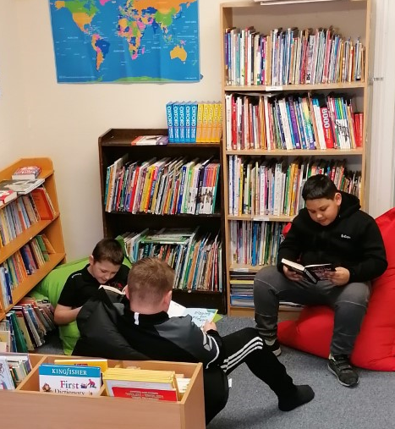
The parents will endeavour to work together at home and in school to ensure good standards of behaviour and a positive attitude towards school and work at all times.
We will work together on the basis of mutual respect to help our students become confident and enthusiastic learners.
Curriculum
The primary aim of our curriculum is to engage reluctant students in the act of learning as a pleasurable and profitable experience. Our students are offered a wide ranging, bespoke and varied curriculum, with an emphasis upon the acquisition of a wide range of skills to develop the holistic needs of the individual.
At key stages 2 and 3 students are taught using a primary class based approach with most subjects being taught by their class teacher. For key stages 4 and 5, a similar class based approach is used but with more flexibility to ensure aspects of the curriculum are covered by specialist teachers. At key stages 4 and 5, pupils also follow individual learning pathways focussing on their needs and future aspirations for after school.
In line with the new curriculum for Wales, pupils work towards four core purposes. They will be the starting point for all decisions on the content and experiences developed as part of the curriculum to support all children and young people to be:
- Ambitious, capable learners ready to learn throughout their lives.
- Enterprising, creative contributors, ready to play a full part in life and work.
- Ethical, informed citizens of Wales and the world.
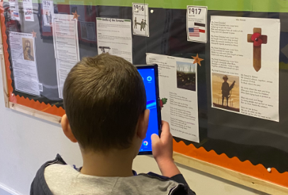
- Healthy, confident individuals, ready to lead fulfilling lives as valued members of society.
These core purposes are incorporated into all aspects of the curriculum and help inform our planning for the six areas of Learning and Experience;
- Expressive arts
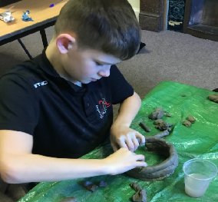
- Health and well-being
- Humanities
- Languages, literacy and communication
- Mathematics and numeracy
- Science and technology.
Areas of continued development in all curriculum areas are the aspects of literacy, numeracy and digital competency. All statutory curriculum requirements are met.
Our students all have a Statement of Special Educational Needs. This forms the basis of all Individual Education Plans which are reviewed on a termly basis. Educational reviews then take place on an annual basis. Full subject reports are produced annually. In addition, students undergo a regular learning and achievement review as part of our internal assessment.

Qualifications
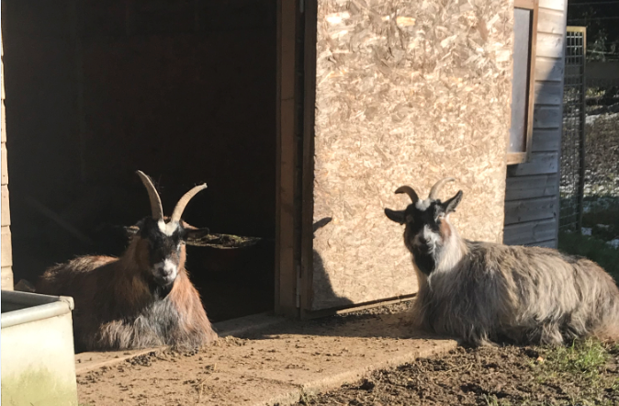
To ensure the needs and aspirations of our pupils continues to be met, our qualifications are reviewed on an annual basis.

BTEC

(Business and Technology Education Council)
Pearson BTEC Agriculture: Level 2
Pearson BTEC Applied Science: Level 1
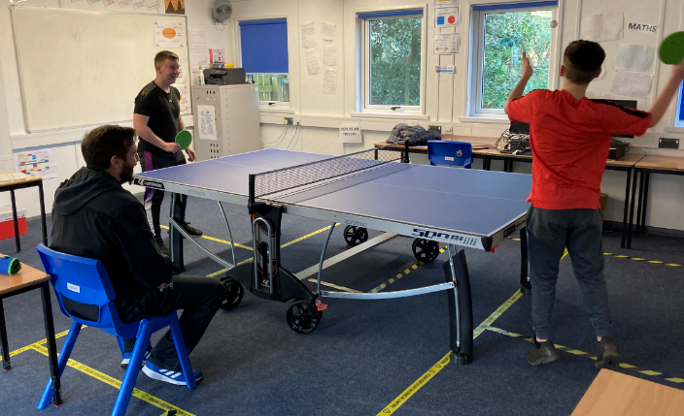
Pearson BTEC Home Cooking Skills: Level 1 / 2
Pearson BTEC Horse Care: Level 2
Pearson BTEC Landbased Studies: Level 1
Pearson BTEC Performing Arts: Level 1
Pearson BTEC Safe Road Skills and Attitudes: Level 1
Pearson BTEC Sport: Level 1
Pearson BTEC Workskills: Level 1
Pearson BTEC Construction: Level 1
Pearson BTEC Vocational: Level 1
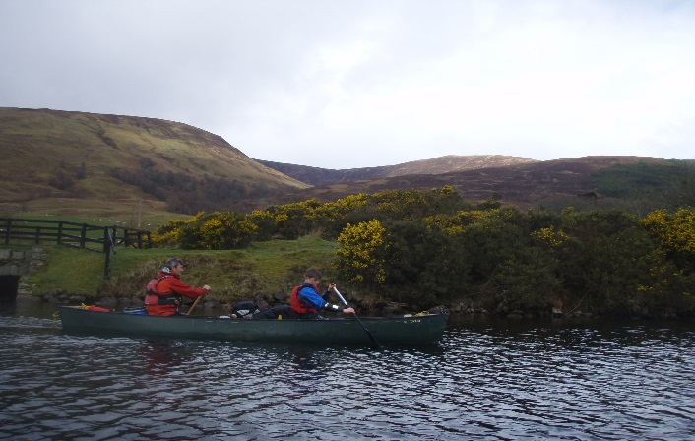

Entry Level / Entry Pathways
WJEC Entry Level: English
WJEC Entry Level: Mathematics
WJEC Entry Level: Science
WJEC Entry Pathways: Humanities
WJEC Entry Pathways: Science Today

Essential Skills Wales
WJEC Essential Skills Wales: Application of Number
WJEC Essential Skills Wales: Communication
WJEC Essential Skills Wales: Digital Literacy Skills

External Agencies
At Brynllywarch Hall School we have formed strong links with external agencies in the community. Working alongside external agencies such as;
Bike to the Future
Careers Wales
Clun Organics
Dairy Dreams
Footsteps on the Farm
Hope Initiatives
Phoenix Project
The Gamechanger Project
This is not an exhaustive list, working alongside external agencies enhances our curriculum and allows our pupils offsite experiences in a safe and well managed environment to complement their time within school and work towards accreditation suited to their needs and future aspirations.
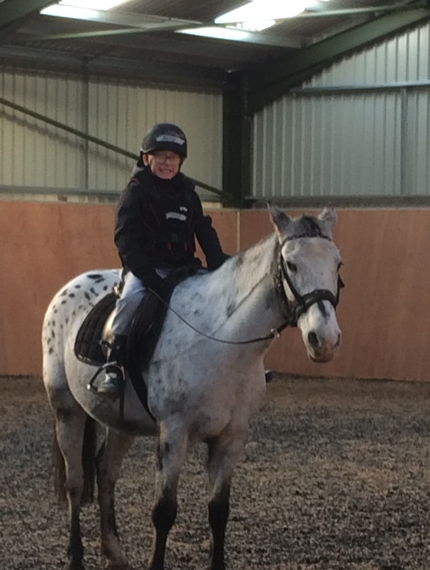
Qualifications delivered by our external agencies include:
ASDAN short courses
Motor Vehicle Studies Level 1 Award / Certificate
Personal and Social Education Level 1 Award

Extra-Curricular
Duke of Edinburgh Award Scheme
Enterprise Projects
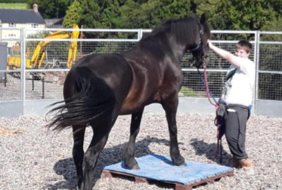
Forest Schools
Horse riding (RDA)
Horticulture
Outdoor Pursuits
Swimming
Trampolining
Work Experience

GCSE
(General Certificate of Secondary Education)
WJEC GCSE English Language
WJEC GCSE Mathematics
WJEC GCSE Applied Science

London Institute for Banking & Finance
Lessons in Financial Education (LiFE) Level 1 Award / Certificate
Lessons in Financial Education (LiFE) Level 2 Award / Certificate

Outreach Service
At Brynllywarch we are proud to have an Outreach Service which offers advice, support and training including:
Individual referrals, observation, assessment and planning
Support and Strategies
Transition support between mainstream to specialist settings
Sharing and modelling good practice
We offer support for all those living and working with:
Anxiety
Attention Deficit Hyperactivity Disorder
Autistic Spectrum Condition
Depression
Moderate Learning Difficulties
Oppositional Defiant Disorder
Social Conduct Disorder
Social, Emotional & Mental Health Difficulties
Stress

Pastoral Care
A child who feels safe, valued and happy is in the best position to gain maximum benefit from time spent in school. We strive to ensure that this is the case in our school.
We have a zero-tolerance on bullying and students are made aware of our anti-bullying policy through their PSE lessons, assemblies and work with KIVA.
We frequently stress to pupils the importance of telling someone if they feel that they are being bullied in any way. We ensure that all of our pupils have access to a trusted, emotionally available adult who can support them. We also ensure pupils have access to trained Emotional, Literacy, Support Assistants to provide emotional and social support and development.
Bullying is a regular topic in assemblies and your child should be left in no doubt as to what action to take if they are bullied.
Form tutors maintain regular contact with parents on a daily / weekly basis.
We provide a dedicated well-being area and students are able to access a variety of support services including counselling, music therapy, animal therapy, art based therapy, rebound therapy and health/lifestyle support from external agencies such as CAIS.

Reward System
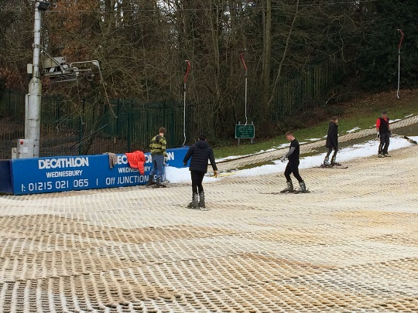
At Brynllywarch we believe hard work should be rewarded and we strive to give our pupils the best possible opportunities. We have a reward system where every pupil can earn up to £10 worth Amazon vouchers per week. In addition to this, pupils can experience offsite trips at the end of a term. Pupil voice is a key factor and where appropriate, helps us inform our activities and rewards. To be eligible for our rewards, pupils need to work towards core expectations within school;
- Being engaged in their classwork
- Being in class
- Being punctual to lessons
- Completing the work set
- Good manners
- Wearing correct uniform.
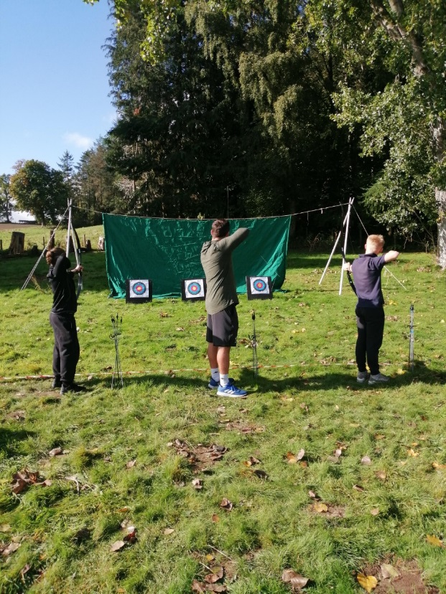
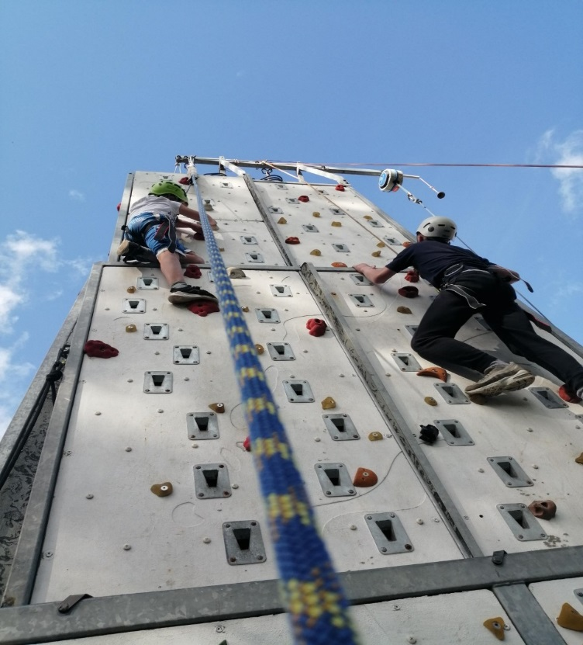
To monitor and track pupil behaviour and engagement, we use Sleuth, an online tool where staff can input positive behaviours and those of a concern. For each lesson pupils can gain points by meeting their core expectations. On occasion, where pupils have exceeded expectations, additional points can be obtained for displaying; compassion, courage, determination, humility and resilience. Extra points are also given to pupils for using the Welsh language. Children on trips and visits are checked in regularly by their teachers. All trips and visits are assessed for risk.

School Uniform

We have a school uniform that we actively encourage student to wear. We believe our uniform adds to the ethos of the school assisting with good behaviour and fostering a strong feeling of belonging amongst the children. Our school colour is black with the school logo displayed on a sweatshirt. School uniform consists of the following:

Sweatshirts (from school) | Black with Logo
Shoes (trainers are not permitted) | Black, low heeled, leather
Boys Uniform | Black Polo Shirt, Black or Grey Trousers. Suitable Coat.
Girls Uniform | Black Polo Shirt, Black Skirt or Trousers. Suitable Coat.
Physical Education | Black Shorts or Joggers,  T-Shirt, football socks & trainers.
Swimming | Swimming trunks (boys)  Swimsuit (Girls) One-piece.

Please note that extreme hair styles and colours are not permitted in school.
Jewellery is not allowed except one small stud or sleeper per ear.

School Timetable

Time | Activity | Total Teaching Time
8:50 am | School open
8:55 – 9:05am | Assembly
9:05 – 10:45am | Teaching Time | 1 hour 40 mins
10:45 – 11:00am | Morning Break
11:00 – 12:40pm | Teaching Time | 1 hour 40 mins
12:40 – 1:20pm | Lunch
1:20 – 1:30pm | Social skills development
1:30 – 3:05pm | Teaching Time | 1 hour 40 mins
3:05pm | Dismissal
 |  | Total 5 hours
Total Teaching Time per Week |  | 25 hours

Term Dates
Autumn Term 2021
Thursday 2nd September 2021 to Friday 22nd October 2021
Half-Term: Monday 25th October 2021 to Friday 29th October 2021
Monday 1st November 2021 to Wednesday 22nd December 2021
Spring Term 2022
Wednesday 5th January 2022 to Friday 18th February 2022

Half-Term: Monday 21st February 2022 to Friday 25th February 2022
Monday 28th February 2022 to Thursday 7th April 2022
Summer Term 2022
Tuesday 26th April 2022 to Friday 27th May 2022

Half-Term: Monday 30th May 2022 to Friday 3rd June 2022

Monday 6th June 2022 to Thursday 14th July 2022
Non-Pupil Days 2021 / 22
Wednesday 1st September 2021
Tuesday 4th January 2022
Friday 8th April 2022
Monday 25th April 2022
Monday 27th June 2022
Friday 15th July 2022
Useful Dates 20/21
Good Friday: Friday 15th April 2022
Easter Monday: Monday 18th April 2022
May Day Bank Holiday: Monday 2nd May 2022
Spring Bank Holiday: Thursday 2nd June 2022
Platinum Jubilee: Friday 3rd June 2022
Royal Welsh Show: Monday 18th July 2022 - Thursday 21st July 2022

Safeguarding your Child
Brynllywarch Hall School is committed to safeguarding your child and to following the recommendations laid out in the Children Act 2004, which broadly states that children and young people have rights of their own, independent of those of their parents, guardians and carers. These rights and responsibilities should be recognised and respected. Mr. Randell is the designated person for Child Protection
To enable all children and young people to achieve their potential, they should:
- Have their basic needs met.
- Enjoy the medical, educational, leisure and welfare services necessary for a healthy and positive childhood.
- Live in a safe environment protected from exploitation, abuse and harm.
- Feel loved and valued and be supported by a network of reliable and affectionate relationships.
- Have a positive image of themselves and a secure sense of identity including cultural and racial identity.
- Be consulted and have views taken into account on all matters and decisions that affect their lives
- Be helped to develop good inter-personal skills and confidence in social situations to enable them to become competent in looking after themselves and coping with everyday living.
- Where there is a conflict of interest between parents and children, and in all decisions relating to their future, the child’s interest must be given primary considerations

School Meals
Breakfast Club / School Snacks
All pupils have breakfast club in their classbase, this includes toast and other refreshments. In addition to this, fruit is available throughout the day. All of our refreshments are free of charge to pupils.

School Meals
Hot and cold meals are available daily and eaten in the school hall.
The School Meals Service operates a “Healthy Eating” policy, which is reflected in the menus offered.
Provision is made for children wishing to bring their own packed lunch to eat in the school hall. Please note that no glass bottles are allowed and we ask you not to include any fizzy drinks. Packed lunch boxes are stored in a designated area. This area is not refrigerated so please consider the contents carefully. At present we have no cool or refrigerated storage areas available to facilitate this. In 2017 all schools in Powys were upgraded to the new cashless system in canteens which is supported through Parent Pay details of this are available from the school office. Our school meals are run by Powys Catering.

Free School Meals & Clothing Grants
Free School Meals are provided for children of parents in receipt of appropriate benefits. Please note that we do not distinguish between paying and non-paying pupils.

Complaints
A formal complaints procedure exists in line with The Education Act 1996 although we hope that you would contact us to discuss any issue informally in the first instance. Should you wish to make a formal complaint, a copy of the procedures can be obtained directly from the school.

School Security
The buildings are protected by intruder alarms and there is perimeter fencing around the school site. Parents must give permission for photographs of pupils to be used in publicity. All visitors to the school must sign in at the main office. Visitors are issued with badges to identify them when walking around the school grounds. All staff are checked by the Data Barring Service.

Brynllywarch Hall School Data

Pupil numbers and gender distribution
Number of pupils by year group 2018 - 19
Year | Boys | Girls
3 | 1 | 0
4 | 1 | 0
5 | 1 | 0
6 | 5 | 0
7 | 4 | 1
8 | 4 | 0
9 | 7 | 0
10 | 6 | 2
11 | 12 | 3
12 | 1 | 0
13 | 2 | 0
14 | 0 | 0
TOTAL | 44 | 6

Number of pupils by year group 2019 - 20
Year | Boys | Girls
3 | 1 | 0
4 | 2 | 0
5 | 1 | 0
6 | 4 | 0
7 | 4 | 0
8 | 4 | 1
9 | 6 | 0
10 | 7 | 0
11 | 6 | 1
12 | 6 | 4
13 | 1 | 0
14 | 2 | 0
TOTAL | 44 | 6

Number of pupils by year group 2020 - 21
Year | Boys | Girls
3 | 0 | 0
4 | 3 | 0
5 | 3 | 0
6 | 4 | 0
7 | 4 | 0
8 | 4 | 1
9 | 5 | 1
10 | 7 | 0
11 | 7 | 0
12 | 5 | 1
13 | 3 | 3
14 | 1 | 0
TOTAL | 46 | 6

Pupil Destination data:

End of KS4 Destination Data.
Destination | 2016 - 17 | 2017 - 18 | 2018 - 19 | 2019-20
College | 1 | 2 | 3 | 2
Employment | 2 | 2 | 1 | 1
6th Form | 2 | 1 | 10 | 6
N.E.E.T | 1 | 1 | 0 | 0
Army | 0 | 0 | 1 | 0

Retention levels for pupils going to Brynllywarch Hall School 6th form continues to remain excellent for end of key stage 4 pupils for 2019 – 20. For the second year, no individual is classed as N.E.E.T (Not in Education, Employment, or Training).The vocational aspect of our curriculum continues to meet the needs and aspirations of our end of key stage 4 pupils who wish to return to 6th form in key stage 5. Overall, there is very strong progress with our end of key stage 4 destination data.

KS5 Destination Data.
Destination | 2017 - 18 | 2018 - 19 | 2019 - 20 | 2020 - 21
College | 2 | 0 | 1 | 2
Employment | 6 | 0 | 3 | 2
Continue 6th Form | 1 | 3 | 7 | 8
Unknown | 0 | 0 | 0 | 1
University | 0 | 0 | 0 | 0
Other 6th Form | 1 | 0 | 0 | 0
N.E.E.T | 0 | 0 | 0 | 0

Most of our key stage 5 pupils have chosen to remain in 6th form for another academic year with the exception of two pupils who have gained employment and another pupil who has started a college course nearer to their home. Our 6th form provision provides pupils with a bespoke timetable that focuses on gaining and improving on existing qualifications whilst developing links with the local community by being involved in work experience placements. The work experience placements are matched to pupils learning pathways to ensure they meet pupils’ needs and future aspirations. This also provides crucial social skills development helping our pupils to become confident and contributing members of society. All key stage 5 pupils have benefit from a work experience placement to develop social skills and links with their local community.

